**Moon and Cake Team Roles**:

Max Yeh: Product Owner

Yao-Wen Chang

Jinson Wu

Yi-Chia Wu

Ya-Ru Yang: Scrum Master (rotated)

**Customer Meeting Date/Time/Place**:

weekly meeting: 10/14, 10/21 via Zoom (9:00-10:00 am every Friday via Zoom)

**Feedback from the Client (mainly from the meeting on 10/14):**

* The primary tasks in the next iteration are dashboard design and email function implementation.
* Had a database that stored emails
* Homepage, login/signup page, and the two-type login worked well and passed tests perfectly

**Current Working Stories**:

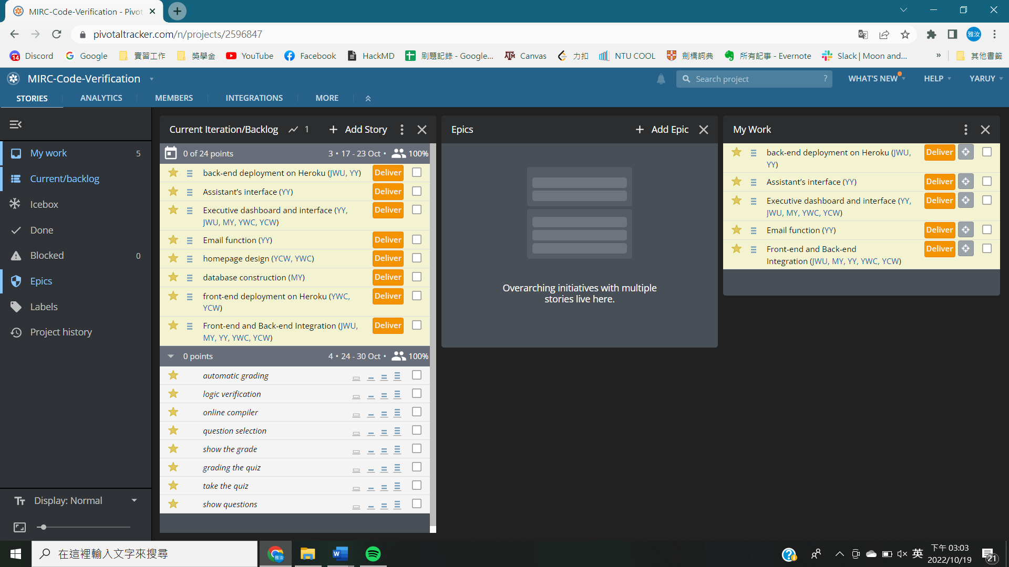

* user stories pick from iteration-1: login via third-party authentication, homepage design, front-end deployment on Heroku, and back-end deployment on Heroku.
  + New user stories (Assistant’s interface, Executive dashboard and interface, and Email functions) were added which could better describe the requirement of the client.
  + Latest details of the two-type login and homemade design were proposed in the meeting last time. The client was eager to concentrate on dashboard design. We are stepping on these added features to meet the requirements and deploying them on the platform.
  + This iteration created a user login interface and system by React and Firebase-Django back-end coordination employed on Heroku, which could identify different users while logging into the website. One was able to have login/signup options by email, and the other through third-party authentication, e.g., Google and Facebook.
  + Primary login/signup page is shown with the functions demonstrated below. Internal back-end integration was completed and currently under the test.
  + Database linked with the user profile is under construction. We now emphasize the combination of backend and add-on profiles within Django framework

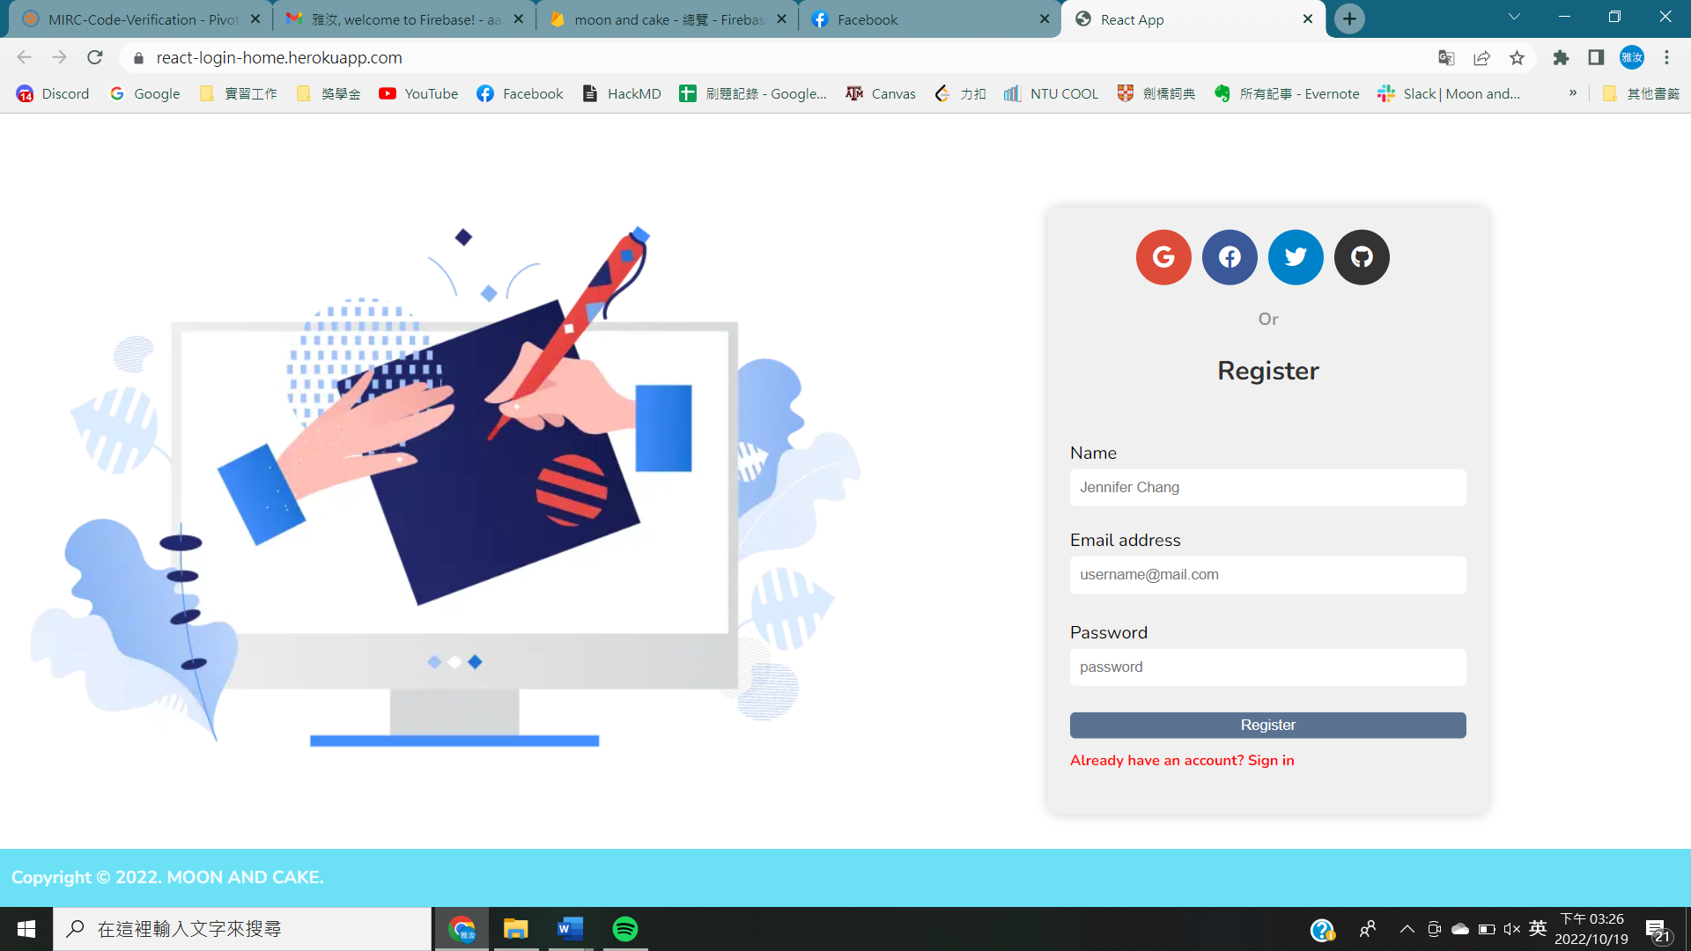

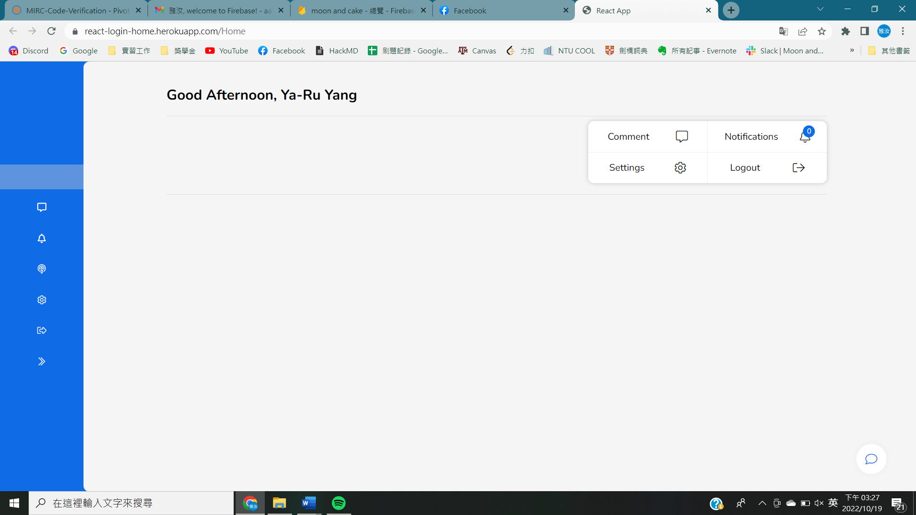

* Test case:
  + Cucumber and RSpec test cases:
    - This will be created after accomplishing the dashboard.
  + BDD: Test an application's behavior from the end user
    - There will be two types of users, one is logged by a google account and the other is by an email-signup account.
    - Different login methods will lead to different text after login (pop-up message then redirect).
  + TDD: testing smaller pieces of functionality
    - type 1: enter username and password
    - type 1: frontend passes the information and interacts with database via backend service
    - type 1: store user information in database
    - type 2: able to access google account (into account selection page)
    - type 2: use google account to login and fetch the basic information from the platform
    - different user types and username give different result (text show on the page)
  + Evaluation (in the next several iterations)
    - Dashboard construction
    - Database reliability test after fully constructed
* UML class diagram

